CS-23334 FUNDAMENTALS OF DATA SCIENCE
ASHWIN C 240701058

Experiment 11 Date: 09.10.2025

11. Random Sampling and Sampling Distribution

Aim:
To explore random sampling from a population and understand the concept of sampling distribution using Python.
Description:
Random sampling and sampling distributions, showing how sample statistics vary across different random samples from a population.
Algorithm:

1. Generate a Population: Create a population of data with a specified distribution
2. Random Sampling: Perform random sampling from the population to create multiple samples of different size and Compute sample statistics (mean, standard deviation, etc.) for each sample.
3. Sampling Distribution: Plot histograms or density plots of sample statistics and compare the sampling distribution of the sample statistic (mean) with the population distribution.
4. Central Limit Theorem: Demonstrate the Central Limit Theorem by showing that as sample size increases, the sampling distribution of the sample mean approaches a normal distribution regardless of the population distribution.

Code With Example:

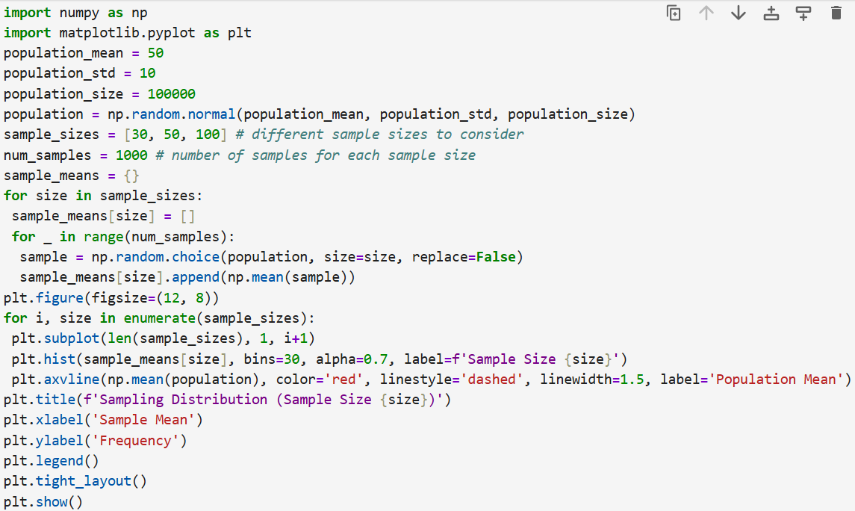

Output:

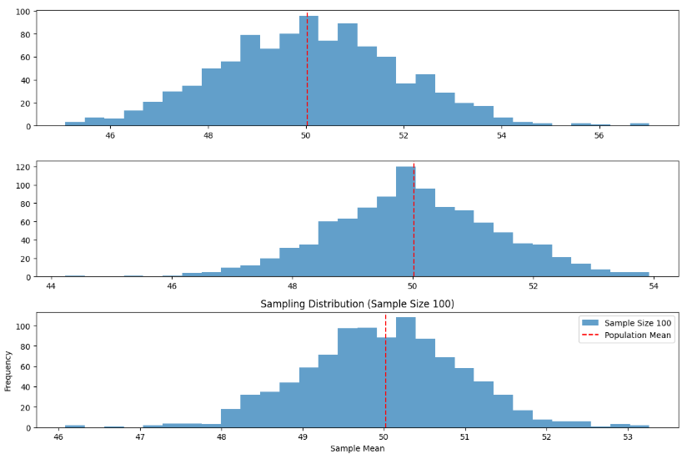

Result:

Thus the python program to explore random sampling from a population was completed.

